JDBC Introduction

JDBC stands for Java Database Connectivity.

Features:

(i) JDBC is a API.

(ii) Connect and execute the query with the database.

(iii) It is a part of JavaSE (Java Standard Edition).

(iv) JDBC API uses JDBC drivers to connect with the database.

There are 4 types of JDBC drivers:

1. JDBC-ODBC (Open Database Connectivity) bridge driver
2. Native-API driver (partially java driver)
3. Network Protocol driver (fully java driver)
4. Thin driver (fully java driver)

* We can use JDBC API to access tabular stored in any relational database.
* We can save, delete, update and fetch data from the database.
* It is based on the X/Open SQL Call Level Interface.

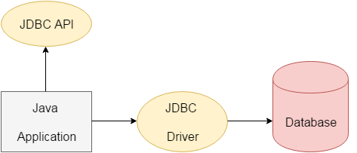

*A list of popular interfaces of JDBC API are given below:*

* Driver interface
* Connection interface
* Statement interface
* PreparedStatement interface
* CallableStatement interface
* ResultSet interface
* ResultSetMetaData interface
* DatabaseMetaData interface
* RowSet interface

Driver Row Database এর ResultSet Connect করতে Prepared হয়ে Statement interface Call করল ।

A list of popular *classes* of JDBC API are given below:

* DriverManager class
* Blob class
* Clob class
* Types class

Why Should We Use JDBC

Before JDBC, ODBC API was the database API to connect and execute the query with the database. But, ODBC API uses ODBC driver which is written in C language (i.e. platform dependent and unsecured). That is why Java has defined its own API (JDBC API) that uses JDBC drivers (written in Java language).